PostgreSQL(Olist Source Database ):
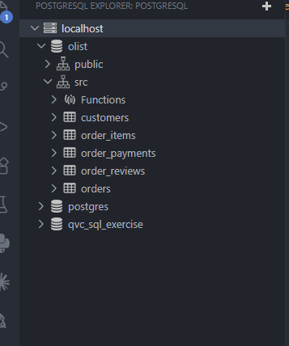
Postgresql is running locally using docker and the above tables are created using the init scipts.
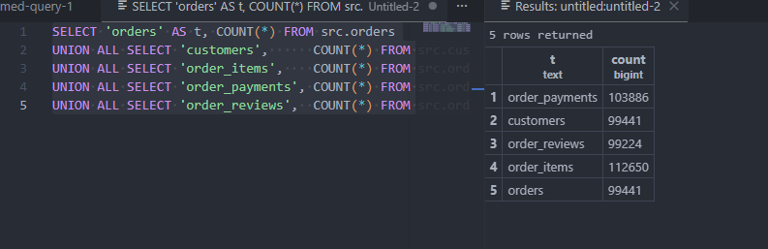
Created an Azure Datafactory for Orchestration:
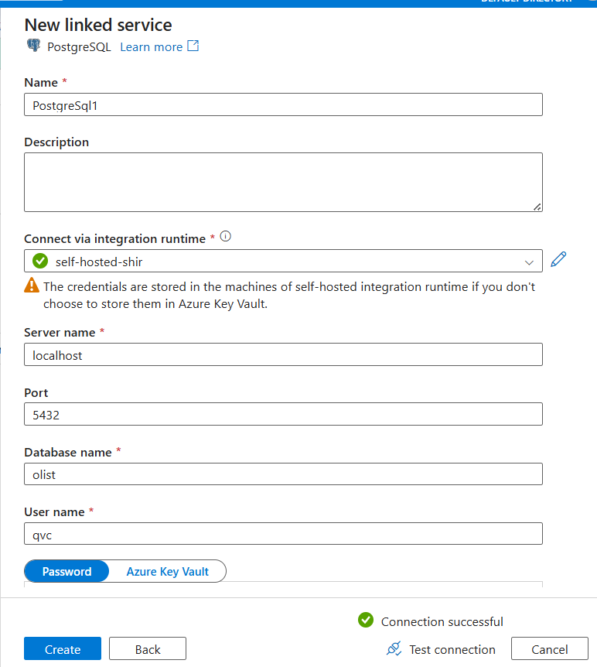
Linked servive to connect to source postgresql
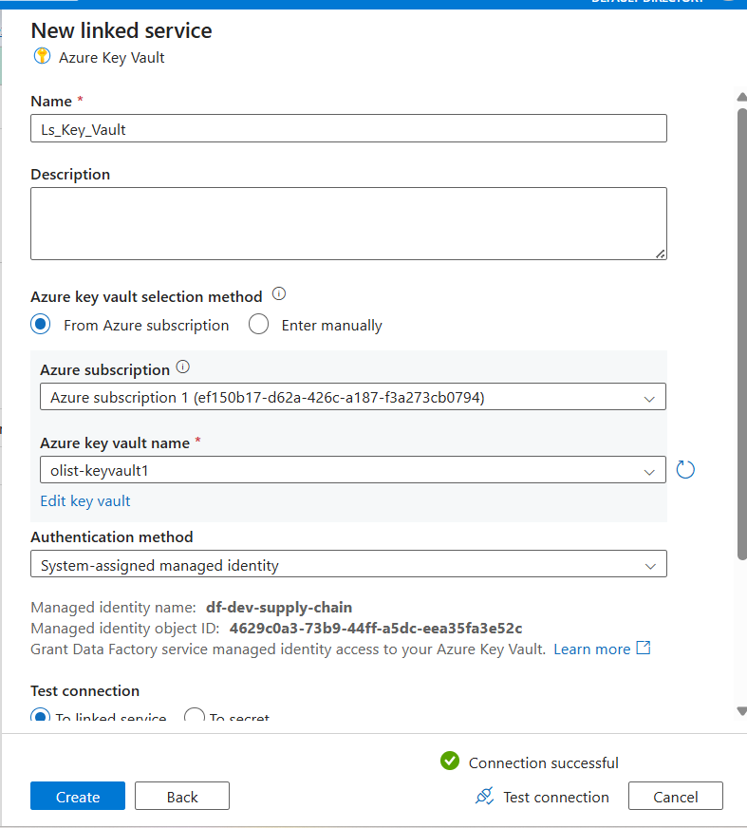
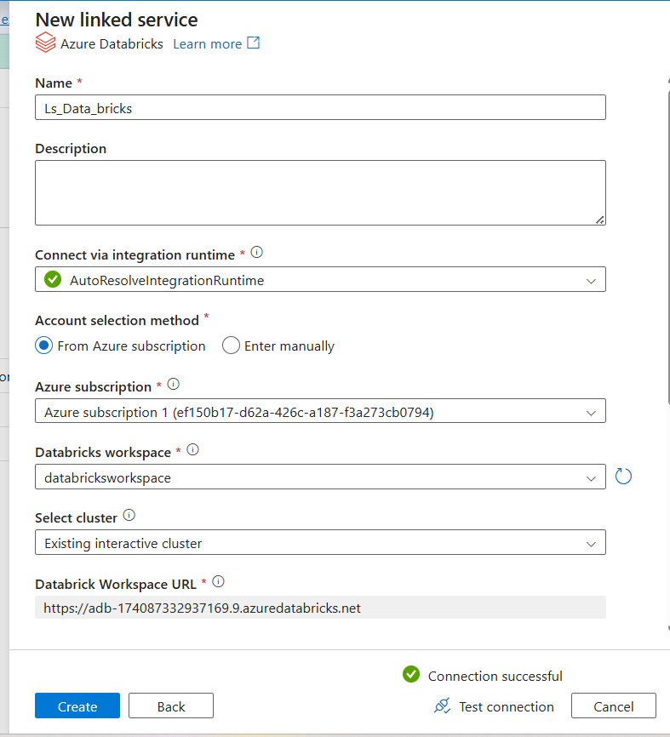
Data Bricks Linked service
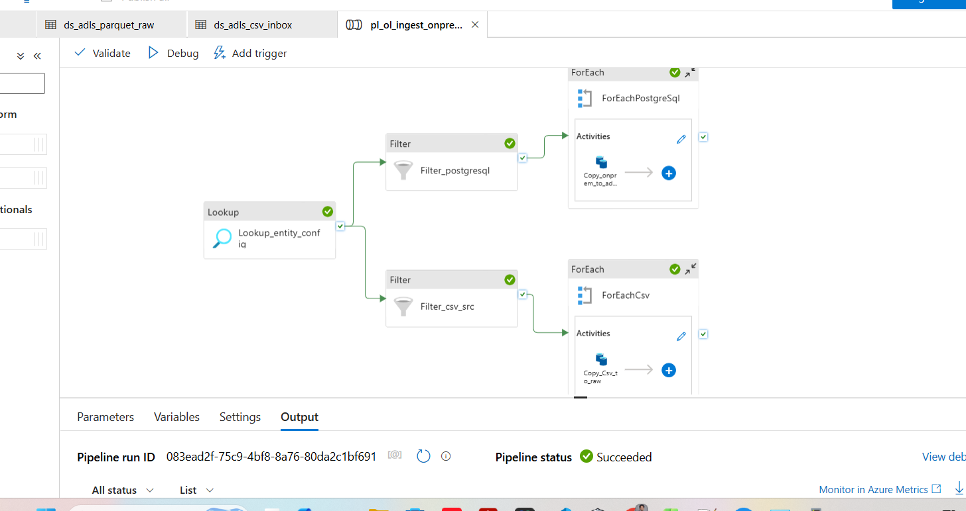
ADF pipeline execution till Raw staging Layer
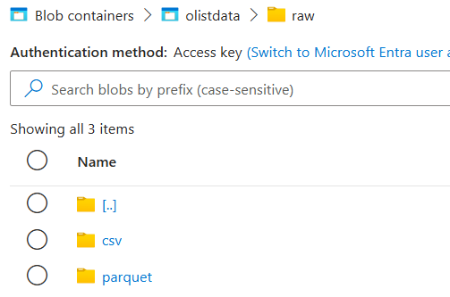
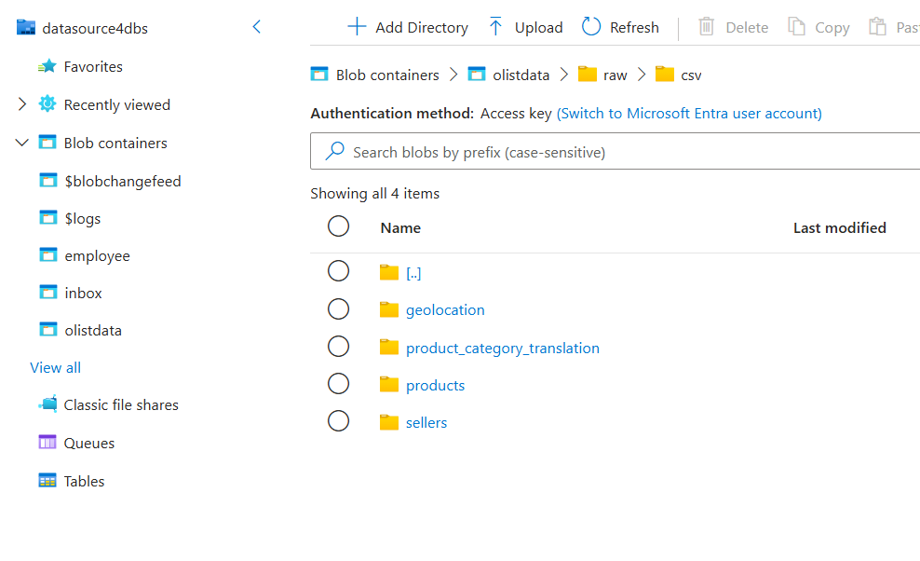
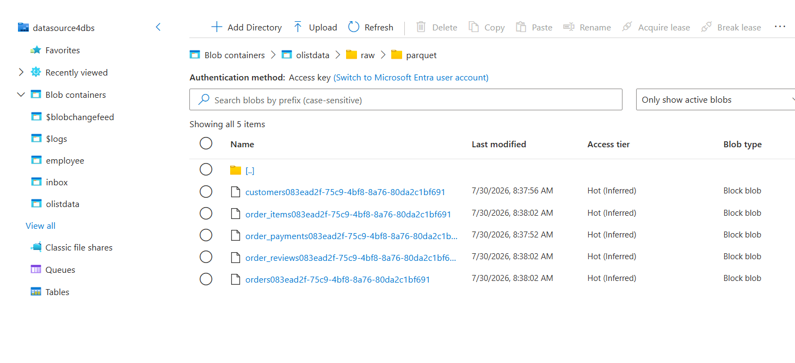
Adf Pipeline run succes full end to end
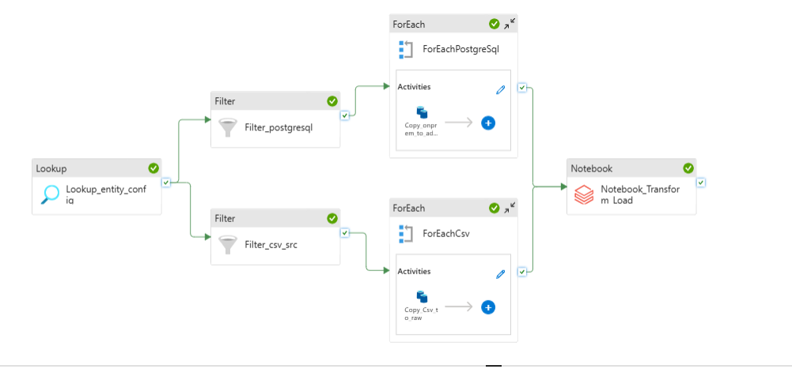
Note book run log scrren shot
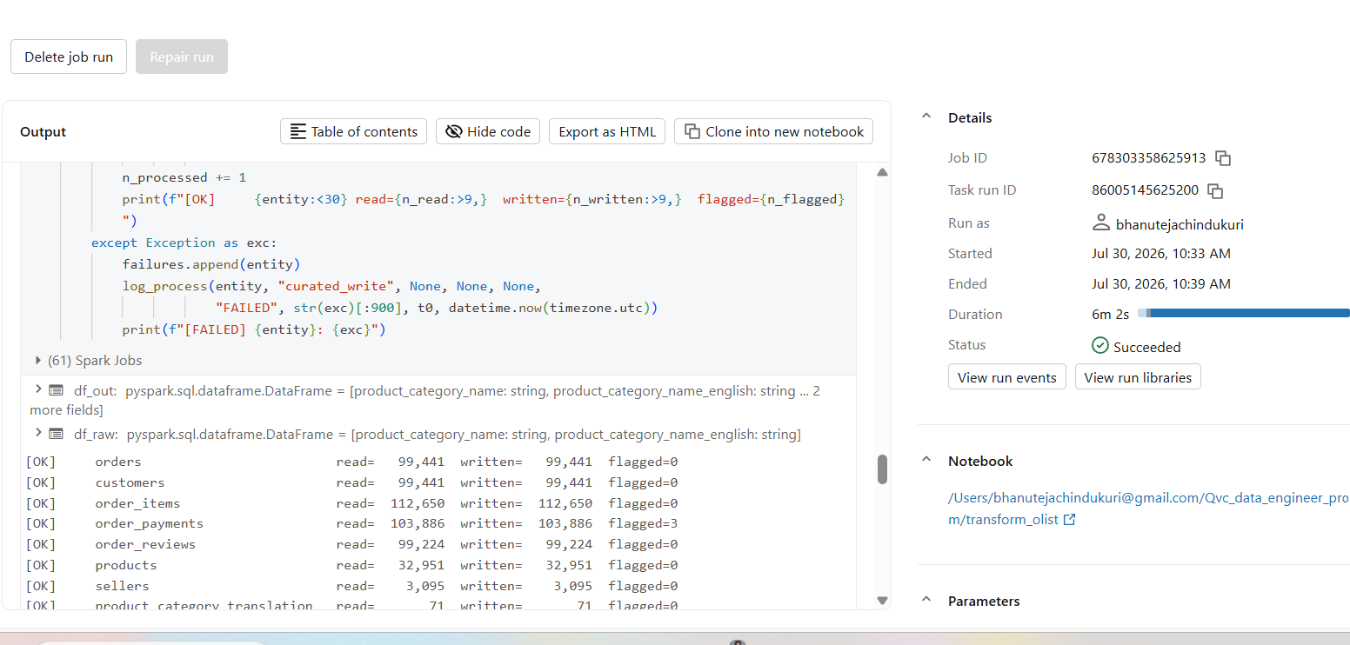
1) Counts check at Curated Layer
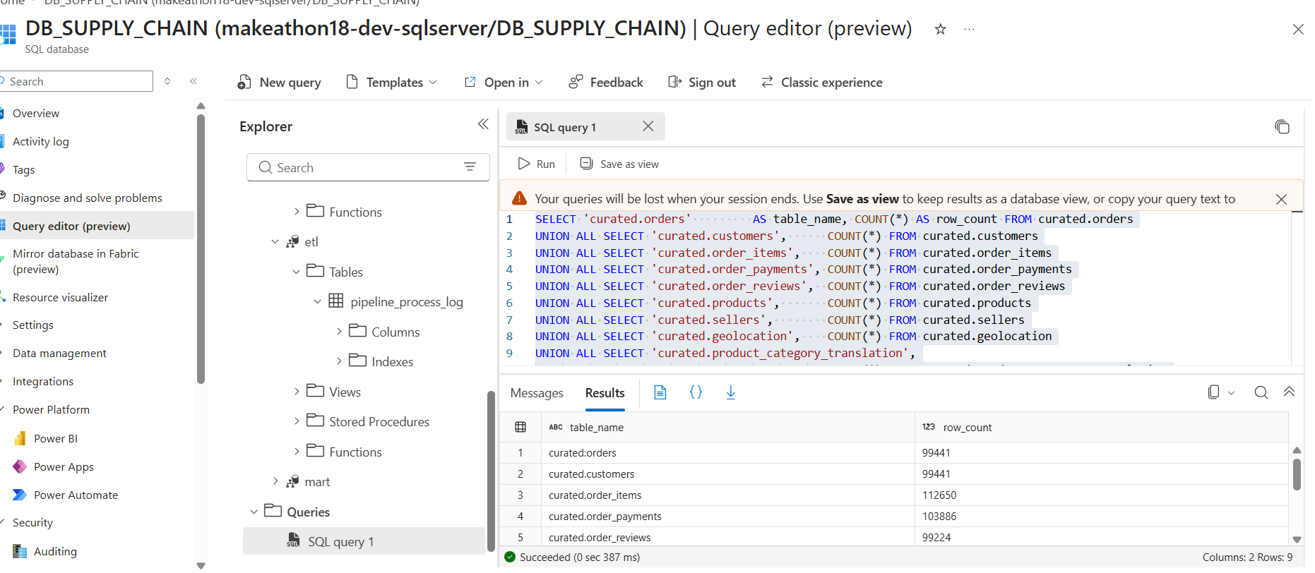
2)
SELECT entity_name, stage, rows_read, rows_written, rows_flagged, status,
started_at_utc, finished_at_utc
FROM etl.pipeline_process_log
WHERE pipeline_run_id = (SELECT TOP 1 pipeline_run_id
FROM etl.pipeline_process_log
ORDER BY logged_at_utc DESC)
ORDER BY logged_at_utc;
Output:
entity_name stage rows_read rows_written rows_flagged status started_at_utc finished_at_utc
orders curated_write 99441 99441 0 SUCCESS 2026-07-30T08:33:52.7055670 2026-07-30T08:34:54.7593130
customers curated_write 99441 99441 0 SUCCESS 2026-07-30T08:35:06.4882590 2026-07-30T08:35:34.5252420
order_items curated_write 112650 112650 0 SUCCESS 2026-07-30T08:35:42.1248950 2026-07-30T08:36:11.8688010
order_payments curated_write 103886 103886 3 SUCCESS 2026-07-30T08:36:19.7804580 2026-07-30T08:36:48.5693390
order_reviews curated_write 99224 99224 0 SUCCESS 2026-07-30T08:36:56.4567170 2026-07-30T08:37:29.9795140
products curated_write 32951 32951 0 SUCCESS 2026-07-30T08:37:37.6156060 2026-07-30T08:37:58.3380530
sellers curated_write 3095 3095 0 SUCCESS 2026-07-30T08:38:06.1553080 2026-07-30T08:38:21.2802550
product_category_translation curated_write 71 71 0 SUCCESS 2026-07-30T08:38:29.1248720 2026-07-30T08:38:41.5622720
geolocation curated_write 1000163 19015 29 SUCCESS 2026-07-30T08:38:49.5356970 2026-07-30T08:39:38.2297090

